1. **INTRODUCTION**
   1. *overview*
      * *Description of the project*

Project Description:

Dream Home Realty, a construction company uses Zoho books to track project expenses manage subcontractor payments and handle invoicing. They can generate estimates and invoices for clients track job costing and monitor the profitability of each project. Zoho books provides them with financial insights to make informed decisions

Purpose:

The zoho books are mainly uses for the purpose of recording the purchase and sales in the real estate business. And it also use to record the accouting transaction to record , analysis , summarize and then gives as a financial reports to make further decision in the business

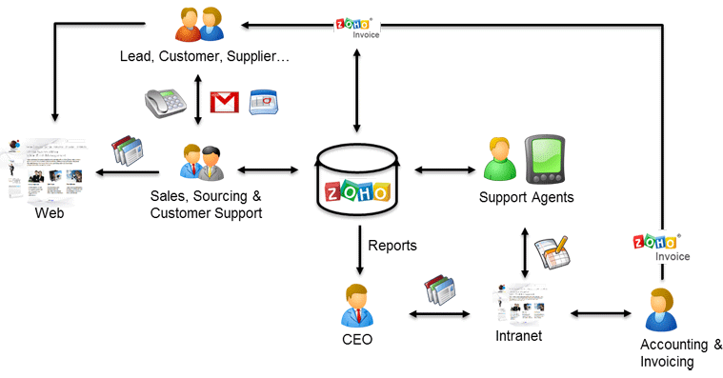

1. **Problem definition & design Thinking**
   1. *Empathy map*

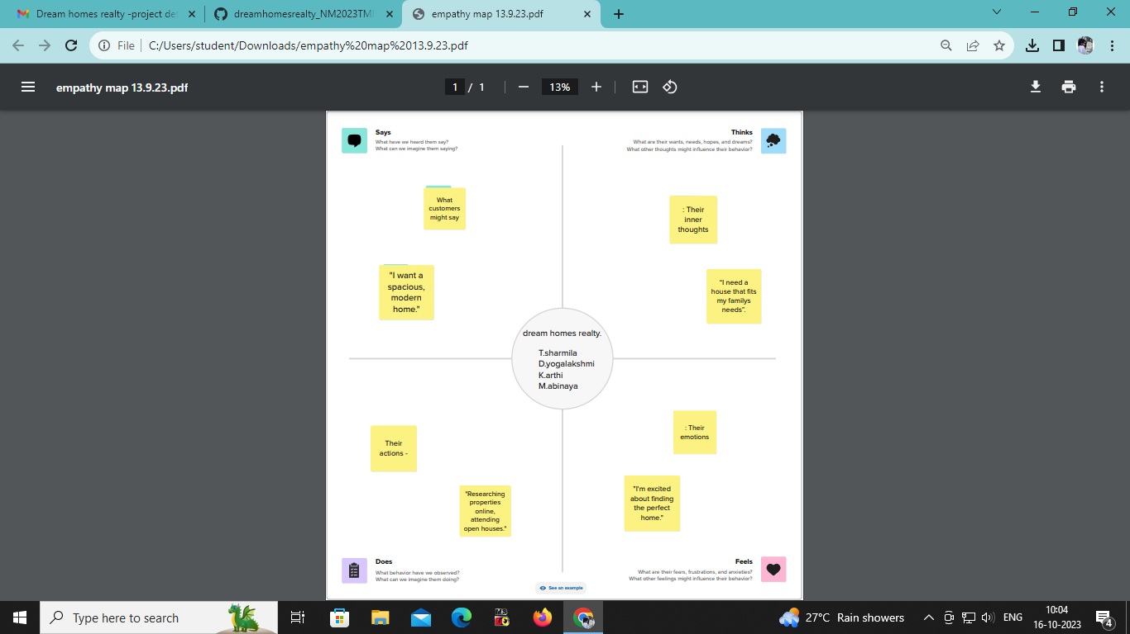

* 1. *Ideation & Brainstorming map*

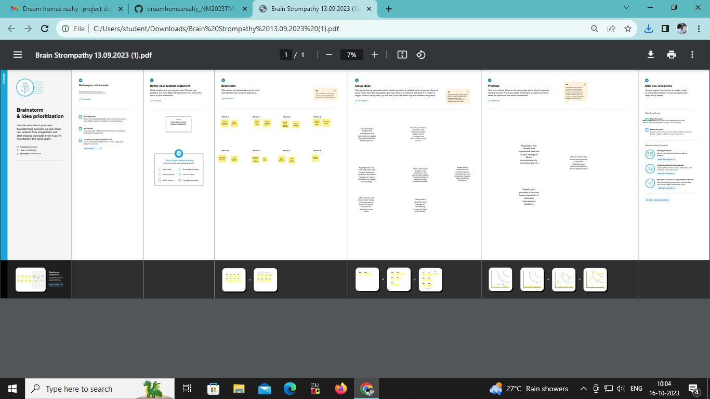

1. **Result Profit&loss**

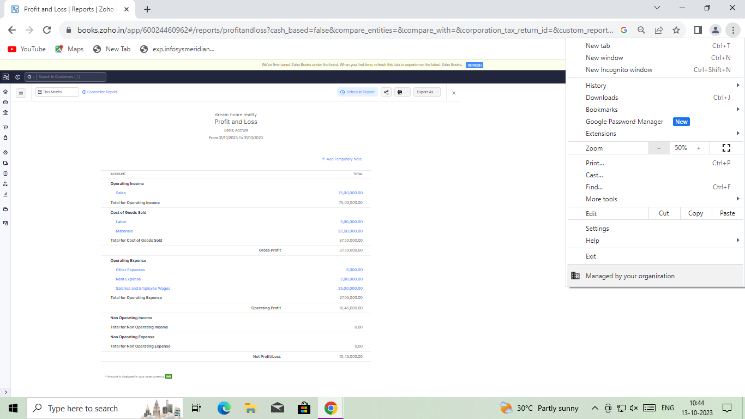

Balance sheet:

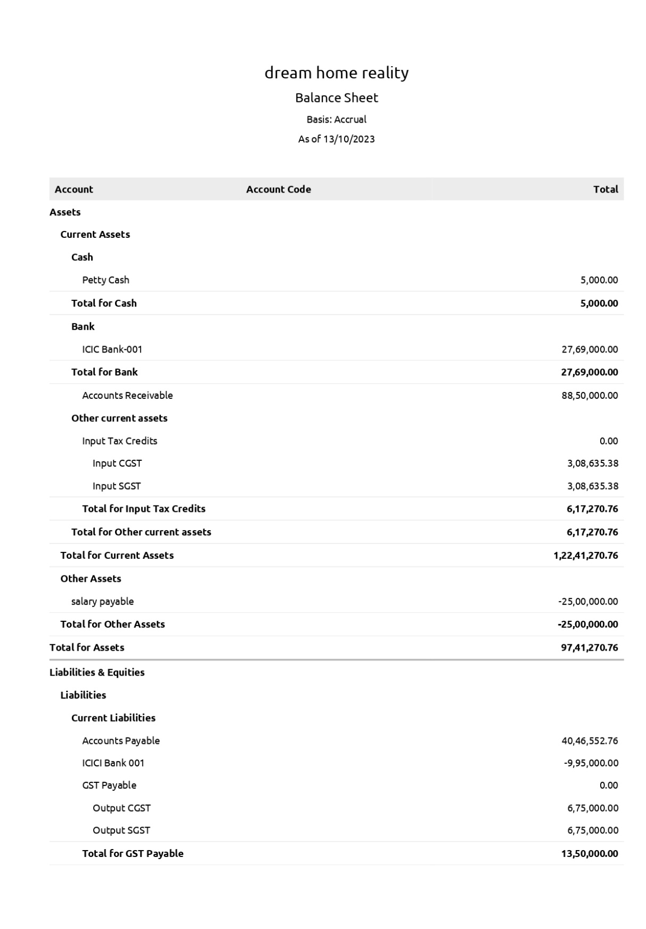

Purchase order:

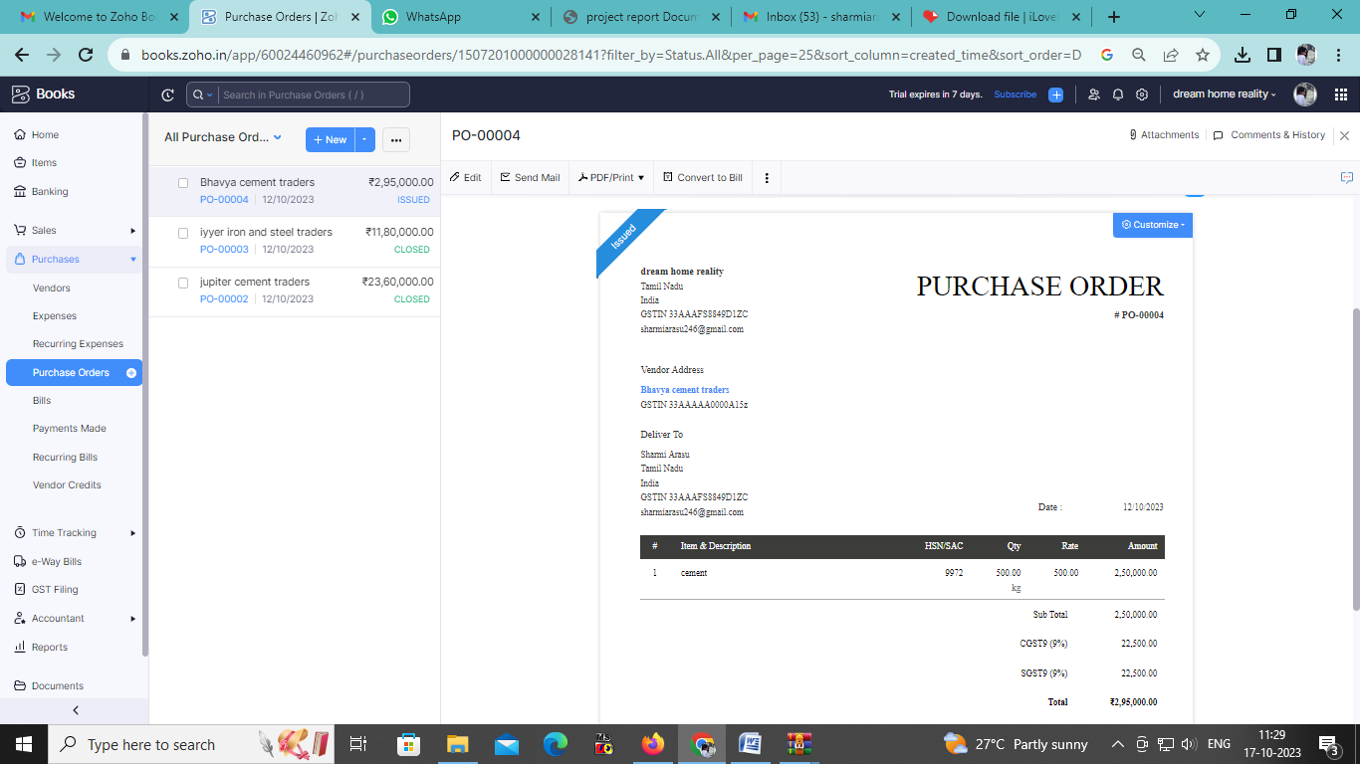

Sales order:

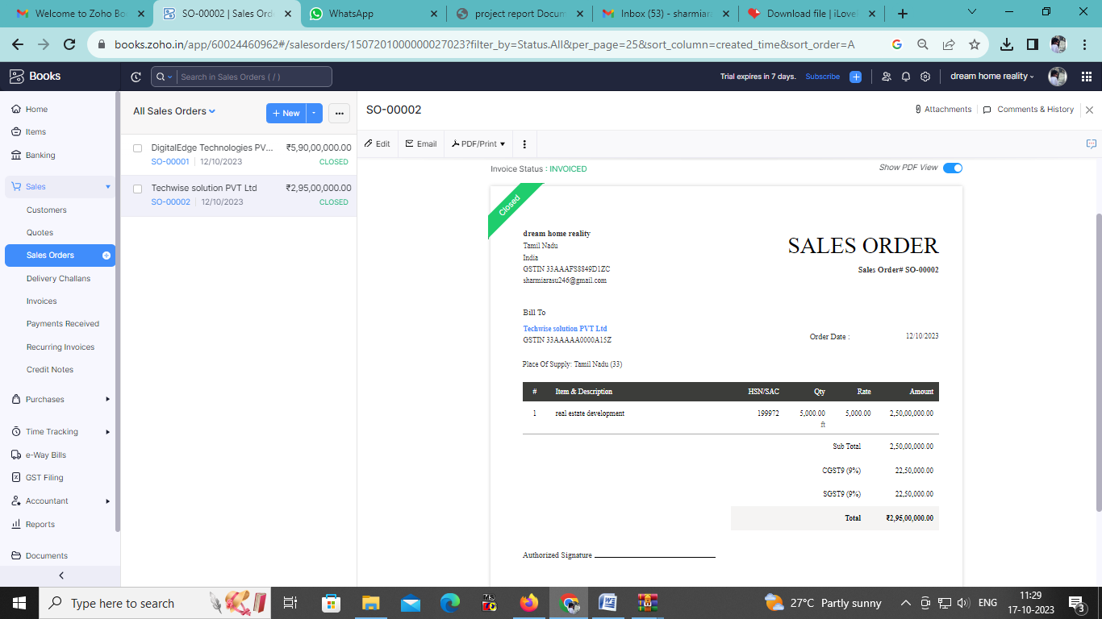

Bills:

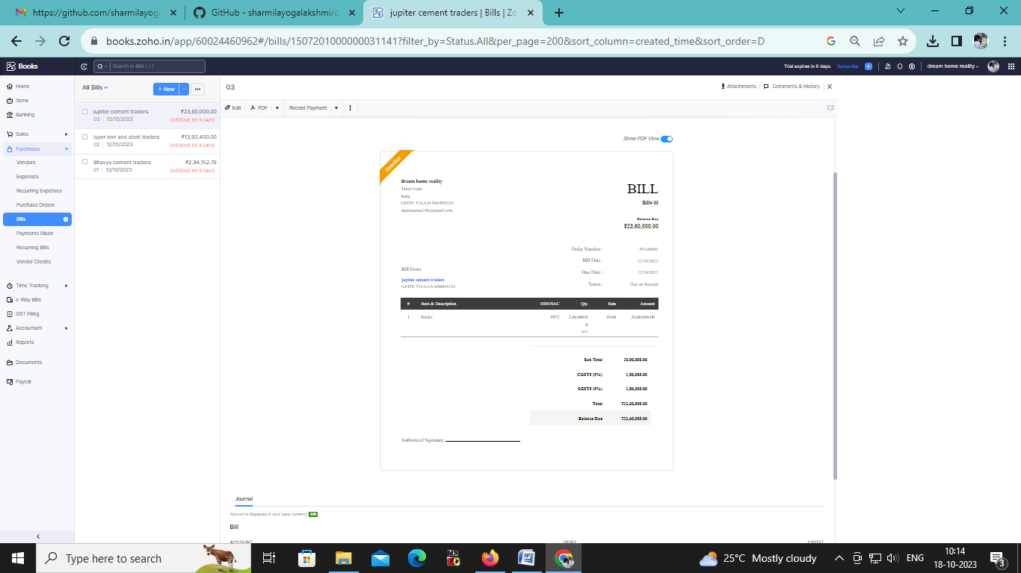

Invoice :

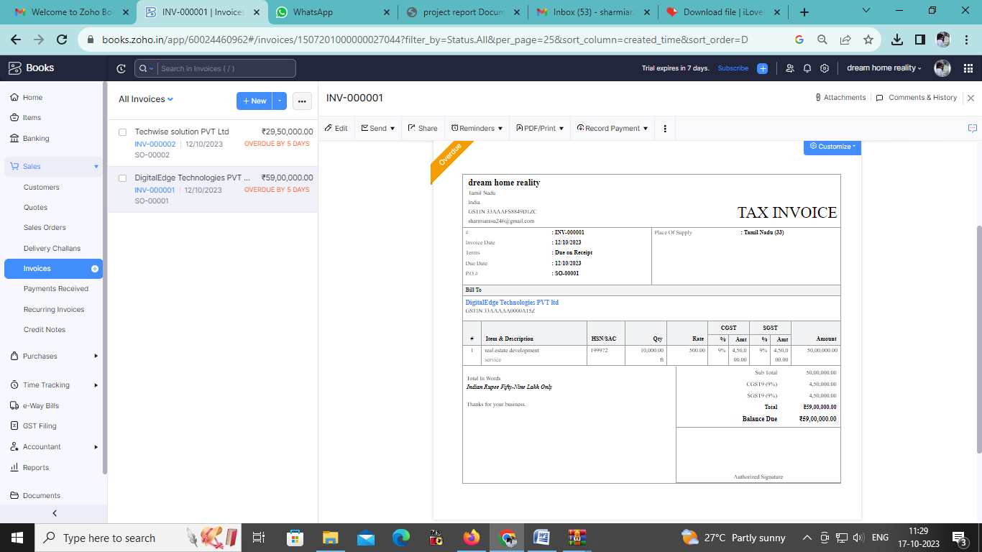

ADVANTAGES :

1. Invoicing and billing
2. Expenses tracking
3. Minimize Data Lost
4. Inventory Management

DISADVANATGES :

1. 1)Difficult to modify invoice
2. Maximum of 10 users
3. Time tracking must be tired to project
4. Limited Bank synking
5. Difficult to modify bills

5)APPLICATION

The zoho books are used to prepare the accounts for the business and also to prepare the bill and invoice for the business. Cloud based accounting software is very in the business. In Dream House Reality uses the Zoho books to track the project Expenses, manage sub-contractor payment and handle invoicing. They can generate estimate and invoices for clint, track job costing, and monitor the profitability of each project

***6)*CONCLUSION:**

The zoho books are usefull to maintain,record,summarize and analysis accounting entries made in this cloud based software. We need any manual records to maintain the accounts. That the transationare recorded while the entering in this software. Then we can add the journal and then we can get the profit and loss A/c, Balance sheet,GST Report and etc. we don’t need one software to enter bill and another software to maintain accounts. We can prepare the bill and maintain accounts in one software

**7)FUTURE SCOPE:**

* it maintain the accounts as well as the billing software in one software
* it provide the financial report to take further decision for the business
* it also help to reduce the work of the accountant to maintain accounts
* it gives less cost for maintain accounts

1. **APPENDIX:**

<https://github.com/sharmilayogalakshmi/dreamhomesrealty_NM2023TMID23158>

|  |
| --- |
| <!DOCTYPE html> |
|  | <html lang="en" data-color-mode="auto" data-light-theme="light" data-dark-theme="dark" data-a11y-animated-images="system" data-a11y-link-underlines="false"> |
|  |  |
|  | <style> |
|  | /* for each iteration, uncomment the CSS variable */ |
|  |  |
|  | /* light themes */ |
|  | [data-color-mode="light"][data-light-theme*="light"], |
|  | [data-color-mode="auto"][data-light-theme*="light"] { |
|  | /* iteration 1 */ |
|  | --border-color-iteration-1: #C8CCD0; |
|  | /* iteration 2 */ |
|  | --border-color-iteration-2: #BABFC5; |
|  | /* iteration 3 */ |
|  | --border-color-iteration-3: #A6ADB4; |
|  | /* iteration final */ |
|  | --border-color-iteration-4: #868F99; |
|  |  |
|  | /* the first value is the final step, which falls back to previous iterations */ |
|  | --control-borderColor-rest: var(--border-color-iteration-4, var(--border-color-iteration-3, var(--border-color-iteration-2, var(--border-color-iteration-1)))) !important; |
|  | } |
|  |  |
|  | /* dark themes */ |
|  | [data-color-mode="dark"][data-dark-theme*="dark"], |
|  | [data-color-mode="auto"][data-light-theme*="dark"] { |
|  | /* iteration 1 */ |
|  | --border-color-iteration-1: #363940; |
|  | /* iteration 2 */ |
|  | --border-color-iteration-2: #3F434B; |
|  | /* iteration 3 */ |
|  | --border-color-iteration-3: #4B5159; |
|  | /* iteration final */ |
|  | --border-color-iteration-4: #666E79; |
|  |  |
|  | /* the first value is the final step, which falls back to previous iterations */ |
|  | --control-borderColor-rest: var(--border-color-iteration-4, var(--border-color-iteration-3, var(--border-color-iteration-2, var(--border-color-iteration-1)))) !important; |
|  | } |
|  |  |
|  | [data-color-mode="dark"][data-dark-theme="dark_dimmed"], |
|  | [data-color-mode="dark"][data-dark-theme="light_high_contrast"], |
|  | [data-color-mode="dark"][data-dark-theme="dark_high_contrast"], |
|  | [data-color-mode="light"][data-light-theme="dark_dimmed"], |
|  | [data-color-mode="light"][data-light-theme="light_high_contrast"], |
|  | [data-color-mode="light"][data-light-theme="dark_high_contrast"] { |
|  | /* skip these themes, use the fallback */ |
|  | --control-borderColor-rest: initial !important; |
|  | } |
|  |  |
|  | @media (prefers-color-scheme: dark) { |
|  | /* dark colors in dark mode */ |
|  | [data-color-mode="auto"][data-dark-theme*="dark"] { |
|  | /* iteration 1 */ |
|  | --border-color-iteration-1: #363940; |
|  | /* iteration 2 */ |
|  | --border-color-iteration-2: #3F434B; |
|  | /* iteration 3 */ |
|  | --border-color-iteration-3: #4B5159; |
|  | /* iteration final */ |
|  | --border-color-iteration-4: #666E79; |
|  |  |
|  | /* the first value is the final step, which falls back to previous iterations */ |
|  | --control-borderColor-rest: var(--border-color-iteration-4, var(--border-color-iteration-3, var(--border-color-iteration-2, var(--border-color-iteration-1)))) !important; |
|  | } |
|  |  |
|  | /* light colors in dark mode */ |
|  | [data-color-mode="auto"][data-dark-theme*="light"] { |
|  | /* iteration 1 */ |
|  | --border-color-iteration-1: #C8CCD0; |
|  | /* iteration 2 */ |
|  | --border-color-iteration-2: #BABFC5; |
|  | /* iteration 3 */ |
|  | --border-color-iteration-3: #A6ADB4; |
|  | /* iteration final */ |
|  | --border-color-iteration-4: #868F99; |
|  |  |
|  | /* the first value is the final step, which falls back to previous iterations */ |
|  | --control-borderColor-rest: var(--border-color-iteration-4, var(--border-color-iteration-3, var(--border-color-iteration-2, var(--border-color-iteration-1)))) !important; |
|  | } |
|  |  |
|  | [data-color-mode="auto"][data-dark-theme="dark_dimmed"], |
|  | [data-color-mode="auto"][data-dark-theme="light_high_contrast"], |
|  | [data-color-mode="auto"][data-dark-theme="dark_high_contrast"] { |
|  | /* skip these themes, use the fallback */ |
|  | --control-borderColor-rest: initial !important; |
|  | } |
|  | } |
|  |  |
|  | @media (prefers-color-scheme: light) { |
|  | /* dark colors in light mode */ |
|  | [data-color-mode="auto"][data-light-theme*="dark"] { |
|  | /* iteration 1 */ |
|  | --border-color-iteration-1: #363940; |
|  | /* iteration 2 */ |
|  | --border-color-iteration-2: #3F434B; |
|  | /* iteration 3 */ |
|  | --border-color-iteration-3: #4B5159; |
|  | /* iteration final */ |
|  | --border-color-iteration-4: #666E79; |
|  |  |
|  | /* the first value is the final step, which falls back to previous iterations */ |
|  | --control-borderColor-rest: var(--border-color-iteration-4, var(--border-color-iteration-3, var(--border-color-iteration-2, var(--border-color-iteration-1)))) !important; |
|  | } |
|  |  |
|  | /* light colors in light mode */ |
|  | [data-color-mode="auto"][data-light-theme*="light"] { |
|  | /* iteration 1 */ |
|  | --border-color-iteration-1: #C8CCD0; |
|  | /* iteration 2 */ |
|  | --border-color-iteration-2: #BABFC5; |
|  | /* iteration 3 */ |
|  | --border-color-iteration-3: #A6ADB4; |
|  | /* iteration final */ |
|  | --border-color-iteration-4: #868F99; |
|  |  |
|  | /* the first value is the final step, which falls back to previous iterations */ |
|  | --control-borderColor-rest: var(--border-color-iteration-4, var(--border-color-iteration-3, var(--border-color-iteration-2, var(--border-color-iteration-1)))) !important; |
|  | } |
|  |  |
|  | [data-color-mode="auto"][data-light-theme="dark_dimmed"], |
|  | [data-color-mode="auto"][data-light-theme="light_high_contrast"], |
|  | [data-color-mode="auto"][data-light-theme="dark_high_contrast"] { |
|  | /* skip these themes, use the fallback */ |
|  | --control-borderColor-rest: initial !important; |
|  | } |
|  | } |
|  | </style> |

<link crossorigin=”anonymous” media=”all” rel=”stylesheet” href=”./NM2023TMID22539_profit_and_loss.pdf at main · asmku643mku643c1c31260_NM2023TMID22539 · GitHub_files/light-b92e9647318f.css”><link crossorigin=”anonymous” media=”all” rel=”stylesheet” href=”./NM2023TMID22539_profit_and_loss.pdf at main · asmku643mku643c1c31260_NM2023TMID22539 · GitHub_files/dark-5d486a4ede8e.css”><link data-color-theme=”dark_dimmed” crossorigin=”anonymous” media=”all” rel=”stylesheet” data-href=https://github.githubassets.com/assets/dark_dimmed-27c8d635e4e5.css><link data-color-theme=”dark_high_contrast” crossorigin=”anonymous” media=”all”

rel=”stylesheet”

data-href=https://github.githubassets.com/assets/dark_high_contrast-8438e75afd36.css><lin k data-color-theme=”dark_colorblind” crossorigin=”anonymous” media=”all” rel=”stylesheet” data-href=https://github.githubassets.com/assets/dark_colorblind-bf5665b96628.css><link data-color-theme=”light_colorblind” crossorigin=”anonymous” media=”all” rel=”stylesheet” data-href=https://github.githubassets.com/assets/light_colorblind-c414b5ba1dce.css><link data-color-theme=”light_high_contrast” crossorigin=”anonymous” media=”all” rel=”stylesheet”

data-href=https://github.githubassets.com/assets/light_high_contrast-e5868b7374db.css><lin k data-color-theme=”light_tritanopia” crossorigin=”anonymous” media=”all” rel=”stylesheet” data-href=https://github.githubassets.com/assets/light_tritanopia-299ac9c64ec0.css><link data-color-theme=”dark_tritanopia” crossorigin=”anonymous” media=”all” rel=”stylesheet” data-href=h[ttps://github.githubassets.com/assets/dark_tritanopia-3a26e78ad0ff.css>](https://github.githubassets.com/assets/light_high_contrast-e5868b7374db.css)

<link cros[sorigin=”anonymous” media=”all” rel=”stylesheet”](https://github.githubassets.com/assets/dark_tritanopia-3a26e78ad0ff.css) href=”./NM2023TMID22539_profit_and_loss.pdf at main · asmku643mku643c1c31260_NM2023TMID22539 · GitHub_files/primer-primitives-6143c8f97ed1.css”>

<link crossorigin=”anonymous” media=”all” rel=”stylesheet” href=”./NM2023TMID22539_profit_and_loss.pdf at main · asmku643mku643c1c31260_NM2023TMID22539 · GitHub_files/primer-d6dcdf72e61d.css”>

<link crossorigin=”anonymous” media=”all” rel=”stylesheet” href=”./NM2023TMID22539_profit_and_loss.pdf at main · asmku643mku643c1c31260_NM2023TMID22539 · GitHub_files/global-ab1c3e3e5644.css”>

<link crossorigin=”anonymous” media=”all” rel=”stylesheet” href=”./NM2023TMID22539_profit_and_loss.pdf at main · asmku643mku643c1c31260_NM2023TMID22539 · GitHub_files/github-757ef6ea9a38.css”>

<link crossorigin=”anonymous” media=”all” rel=”stylesheet” href=”./NM2023TMID22539_profit_and_loss.pdf at main · asmku643mku643c1c31260_NM2023TMID22539 · GitHub_files/code-71ecd5638fbf.css”>

<script type=”application/json”

id=”client-env”>{“locale”:”en”,”featureFlags”:[“failbot_handle_non_errors”,”geojson_azure_m aps”,”image_metric_tracking”,”turbo_experiment_risky”,”sample_network_conn_type”]}</scri pt>

<script crossorigin=”anonymous” defer=”defer” type=”application/javascript” src=”./NM2023TMID22539_profit_and_loss.pdf at main · asmku643mku643c1c31260_NM2023TMID22539 ·

GitHub_files/wp-runtime-86f14561f3b0.js.download”></script>

<script crossorigin=”anonymous” defer=”defer” type=”application/javascript” src=”./NM2023TMID22539_profit_and_loss.pdf at main · asmku643mku643c1c31260_NM2023TMID22539 ·

GitHub_files/vendors-node_modules_dompurify_dist_purify_js-64d590970fa6.js.download”>

</script>

<script crossorigin=”anonymous” defer=”defer” type=”application/javascript” src=”./NM2023TMID22539_profit_and_loss.pdf at main · asmku643mku643c1c31260_NM2023TMID22539 ·

GitHub_files/vendors-node_modules_stacktrace-parser_dist_stack-trace-parser_esm_js-node_ modules_github_bro-a4c183-18bf85b8e9f4.js.download”></script>

<script crossorigin=”anonymous” defer=”defer” type=”application/javascript” src=”./NM2023TMID22539_profit_and_loss.pdf at main · asmku643mku643c1c31260_NM2023TMID22539 ·

GitHub_files/ui_packages_soft-nav_soft-nav_ts-56133143b228.js.download”></script>

<script crossorigin=”anonymous” defer=”defer” type=”application/javascript” src=”./NM2023TMID22539_profit_and_loss.pdf at main · asmku643mku643c1c31260_NM2023TMID22539 ·

GitHub_files/environment-fc6543d75794.js.download”></script>

<script crossorigin=”anonymous” defer=”defer” type=”application/javascript” src=”./NM2023TMID22539_profit_and_loss.pdf at main · asmku643mku643c1c31260_NM2023TMID22539 ·

GitHub_files/vendors-node_modules_github_selector-observer_dist_index_esm_js-2646a2c53 3e3.js.download”></script>

<script crossorigin=”anonymous” defer=”defer” type=”application/javascript” src=”./NM2023TMID22539_profit_and_loss.pdf at main · asmku643mku643c1c31260_NM2023TMID22539 ·

GitHub_files/vendors-node_modules_primer_behaviors_dist_esm_focus-zone_js-d55308df50 23.js.download”></script>

<script crossorigin=”anonymous” defer=”defer” type=”application/javascript” src=”./NM2023TMID22539_profit_and_loss.pdf at main · asmku643mku643c1c31260_NM2023TMID22539 ·

GitHub_files/vendors-node_modules_github_relative-time-element_dist_index_js-99e288659 d4f.js.download”></script>

<script crossorigin=”anonymous” defer=”defer” type=”application/javascript” src=”./NM2023TMID22539_profit_and_loss.pdf at main · asmku643mku643c1c31260_NM2023TMID22539 ·

GitHub_files/vendors-node_modules_fzy_js_index_js-node_modules_github_combobox-nav_ dist_index_js-node_modu-344bff-91b70bb50d68.js.download”></script>

<script crossorigin=”anonymous” defer=”defer” type=”application/javascript” src=”./NM2023TMID22539_profit_and_loss.pdf at main · asmku643mku643c1c31260_NM2023TMID22539 ·

GitHub_files/vendors-node_modules_delegated-events_dist_index_js-node_modules_github_ auto-complete-element-81d69b-f766607dc0c8.js.download”></script>

<script crossorigin=”anonymous” defer=”defer” type=”application/javascript” src=”./NM2023TMID22539_profit_and_loss.pdf at main · asmku643mku643c1c31260_NM2023TMID22539 ·

GitHub_files/vendors-node_modules_github_filter-input-element_dist_index_js-node_module s_github_remote-inp-2e8678-d593bf262480.js.download”></script>

<script crossorigin=”anonymous” defer=”defer” type=”application/javascript” src=”./NM2023TMID22539_profit_and_loss.pdf at main · asmku643mku643c1c31260_NM2023TMID22539 ·

GitHub_files/vendors-node_modules_github_file-attachment-element_dist_index_js-node_m odules_primer_view-co-70ad06-9f8bb7e4a8fa.js.download”></script>

<script crossorigin=”anonymous” defer=”defer” type=”application/javascript” src=”./NM2023TMID22539_profit_and_loss.pdf at main · asmku643mku643c1c31260_NM2023TMID22539 ·

GitHub_files/github-elements-30961cfd137b.js.download”></script>

<script crossorigin=”anonymous” defer=”defer” type=”application/javascript” src=”./NM2023TMID22539_profit_and_loss.pdf at main · asmku643mku643c1c31260_NM2023TMID22539 ·

GitHub_files/element-registry-e5f51987a7c5.js.download”></script>

<script crossorigin=”anonymous” defer=”defer” type=”application/javascript” src=”./NM2023TMID22539_profit_and_loss.pdf at main · asmku643mku643c1c31260_NM2023TMID22539 ·

GitHub_files/vendors-node_modules_lit-html_lit-html_js-4ccebb6ebf7d.js.download”></script

>

<script crossorigin=”anonymous” defer=”defer” type=”application/javascript” src=”./NM2023TMID22539_profit_and_loss.pdf at main · asmku643mku643c1c31260_NM2023TMID22539 ·

GitHub_files/vendors-node_modules_github_mini-throttle_dist_index_js-node_modules_gith ub_alive-client_dist-bf5aa2-504c8d53fb8e.js.download”></script>

<script crossorigin=”anonymous” defer=”defer” type=”application/javascript” src=”./NM2023TMID22539_profit_and_loss.pdf at main · asmku643mku643c1c31260_NM2023TMID22539 ·

GitHub_files/vendors-node_modules_morphdom_dist_morphdom-esm_js-b1fdd7158cf0.js.do wnload”></script>

<script crossorigin=”anonymous” defer=”defer” type=”application/javascript” src=”./NM2023TMID22539_profit_and_loss.pdf at main · asmku643mku643c1c31260_NM2023TMID22539 ·

GitHub_files/vendors-node_modules_github_turbo_dist_turbo_es2017-esm_js-9a3541181451

.js.download”></script>

<script crossorigin=”anonymous” defer=”defer” type=”application/javascript” src=”./NM2023TMID22539_profit_and_loss.pdf at main · asmku643mku643c1c31260_NM2023TMID22539 ·

GitHub_files/vendors-node_modules_github_remote-form_dist_index_js-node_modules_scrol l-anchoring_dist_scro-52dc4b-e1e33bfc0b7e.js.download”></script>

<script crossorigin=”anonymous” defer=”defer” type=”application/javascript” src=”./NM2023TMID22539_profit_and_loss.pdf at main · asmku643mku643c1c31260_NM2023TMID22539 ·

GitHub_files/vendors-node_modules_color-convert_index_js-35b3ae68c408.js.download”></s cript>

<script crossorigin=”anonymous” defer=”defer” type=”application/javascript” src=”./NM2023TMID22539_profit_and_loss.pdf at main · asmku643mku643c1c31260_NM2023TMID22539 ·

GitHub_files/vendors-node_modules_primer_behaviors_dist_esm_dimensions_js-node_modu les_github_jtml_lib_index_js-a18147cea3a6.js.download”></script>

<script crossorigin=”anonymous” defer=”defer” type=”application/javascript” src=”./NM2023TMID22539_profit_and_loss.pdf at main ·

asmku643mku643c1c31260_NM2023TMID22539 ·

GitHub_files/vendors-node_modules_github_paste-markdown_dist_index_esm_js-node_mod ules_github_quote-select-581a1f-4a3074d34892.js.download”></script>

<script crossorigin=”anonymous” defer=”defer” type=”application/javascript” src=”./NM2023TMID22539_profit_and_loss.pdf at main · asmku643mku643c1c31260_NM2023TMID22539 · GitHub_files/app_assets_modules_github_details-dialog_ts-app_assets_modules_github_fetc h_ts-add1ab03ecb3.js.download”></script>

<script crossorigin=”anonymous” defer=”defer” type=”application/javascript” src=”./NM2023TMID22539_profit_and_loss.pdf at main · asmku643mku643c1c31260_NM2023TMID22539 · GitHub_files/app_assets_modules_github_updatable-content_ts-ui_packages_hydro-analytics

_hydro-analytics_ts-0a5a30c9b976.js.download”></script>

<script crossorigin=”anonymous” defer=”defer” type=”application/javascript” src=”./NM2023TMID22539_profit_and_loss.pdf at main · asmku643mku643c1c31260_NM2023TMID22539 · GitHub_files/app_assets_modules_github_onfocus_ts-app_assets_modules_github_sticky-scr oll-into-view_ts-c56a5dfc8975.js.download”></script>

<script crossorigin=”anonymous” defer=”defer” type=”application/javascript” src=”./NM2023TMID22539_profit_and_loss.pdf at main · asmku643mku643c1c31260_NM2023TMID22539 · GitHub_files/app_assets_modules_github_behaviors_task-list_ts-app_assets_modules_github

_sso_ts-ui_packages-7d50ad-9491f2be61ee.js.download”></script>

<script crossorigin=”anonymous” defer=”defer” type=”application/javascript” src=”./NM2023TMID22539_profit_and_loss.pdf at main · asmku643mku643c1c31260_NM2023TMID22539 · GitHub_files/app_assets_modules_github_behaviors_ajax-error_ts-app_assets_modules_gith ub_behaviors_include-2e2258-d77f85c54572.js.download”></script>

<script crossorigin=”anonymous” defer=”defer” type=”application/javascript” src=”./NM2023TMID22539_profit_and_loss.pdf at main · asmku643mku643c1c31260_NM2023TMID22539 · GitHub_files/app_assets_modules_github_behaviors_commenting_edit_ts-app_assets_modul es_github_behaviors_ht-83c235-f22ac6b94445.js.download”></script>

<script crossorigin=”anonymous” defer=”defer” type=”application/javascript” src=”./NM2023TMID22539_profit_and_loss.pdf at main · asmku643mku643c1c31260_NM2023TMID22539 ·

GitHub_files/behaviors-8e3546d05c82.js.download”></script>

<script crossorigin=”anonymous” defer=”defer” type=”application/javascript” src=”./NM2023TMID22539_profit_and_loss.pdf at main · asmku643mku643c1c31260_NM2023TMID22539 ·

GitHub_files/vendors-node_modules_delegated-events_dist_index_js-node_modules_github_ catalyst_lib_index_js-623425af41e1.js.download”></script>

<script crossorigin=”anonymous” defer=”defer” type=”application/javascript” src=”./NM2023TMID22539_profit_and_loss.pdf at main · asmku643mku643c1c31260_NM2023TMID22539 ·

GitHub_files/notifications-global-0104a8043aa4.js.download”></script>

<script crossorigin=”anonymous” defer=”defer” type=”application/javascript” src=”./NM2023TMID22539_profit_and_loss.pdf at main · asmku643mku643c1c31260_NM2023TMID22539 ·

GitHub_files/vendors-node_modules_optimizely_optimizely-sdk_dist_optimizely_browser_es

_min_js-node_modules-089adc-8794271c9a65.js.download”></script>

<script crossorigin=”anonymous” defer=”defer” type=”application/javascript” src=”./NM2023TMID22539_profit_and_loss.pdf at main · asmku643mku643c1c31260_NM2023TMID22539 ·

GitHub_files/optimizely-b8ae60018b11.js.download”></script>

<script crossorigin=”anonymous” defer=”defer” type=”application/javascript” src=”./NM2023TMID22539_profit_and_loss.pdf at main · asmku643mku643c1c31260_NM2023TMID22539 ·

GitHub_files/vendors-node_modules_virtualized-list_es_index_js-node_modules_github_tem plate-parts_lib_index_js-677582870bfd.js.download”></script>

<script crossorigin=”anonymous” defer=”defer” type=”application/javascript” src=”./NM2023TMID22539_profit_and_loss.pdf at main · asmku643mku643c1c31260_NM2023TMID22539 ·

GitHub_files/vendors-node_modules_github_remote-form_dist_index_js-node_modules_dele gated-events_dist_inde-c537341-13ba07af3b2c.js.download”></script>

<script crossorigin=”anonymous” defer=”defer” type=”application/javascript” src=”./NM2023TMID22539_profit_and_loss.pdf at main · asmku643mku643c1c31260_NM2023TMID22539 · GitHub_files/app_assets_modules_github_ref-selector_ts-cad36de2ca60.js.download”></scrip t>

<script crossorigin=”anonymous” defer=”defer” type=”application/javascript” src=”./NM2023TMID22539_profit_and_loss.pdf at main ·

asmku643mku643c1c31260_NM2023TMID22539 · GitHub_files/codespaces-d5d24842ceda.js.download”></script>

<script crossorigin=”anonymous” defer=”defer” type=”application/javascript” src=”./NM2023TMID22539_profit_and_loss.pdf at main · asmku643mku643c1c31260_NM2023TMID22539 ·

GitHub_files/vendors-node_modules_github_filter-input-element_dist_index_js-node_module s_github_mini-throt-08ab15-d50c69097a3e.js.download”></script>

<script crossorigin=”anonymous” defer=”defer” type=”application/javascript” src=”./NM2023TMID22539_profit_and_loss.pdf at main · asmku643mku643c1c31260_NM2023TMID22539 ·

GitHub_files/vendors-node_modules_github_file-attachment-element_dist_index_js-node_m odules_github_mini-th-55cf52-b2acd5425c7c.js.download”></script>

<script crossorigin=”anonymous” defer=”defer” type=”application/javascript” src=”./NM2023TMID22539_profit_and_loss.pdf at main · asmku643mku643c1c31260_NM2023TMID22539 ·

GitHub_files/repositories-b80504a04cf8.js.download”></script>

<script crossorigin=”anonymous” defer=”defer” type=”application/javascript” src=”./NM2023TMID22539_profit_and_loss.pdf at main · asmku643mku643c1c31260_NM2023TMID22539 ·

GitHub_files/vendors-node_modules_github_remote-form_dist_index_js-node_modules_dele gated-events_dist_inde-0e9dbe-6435366f0862.js.download”></script>

<script crossorigin=”anonymous” defer=”defer” type=”application/javascript” src=”./NM2023TMID22539_profit_and_loss.pdf at main · asmku643mku643c1c31260_NM2023TMID22539 ·

GitHub_files/topic-suggestions-2e55863e3751.js.download”></script>

<script crossorigin=”anonymous” defer=”defer” type=”application/javascript” src=”./NM2023TMID22539_profit_and_loss.pdf at main · asmku643mku643c1c31260_NM2023TMID22539 ·

GitHub_files/code-menu-6bd50a0647d6.js.download”></script>

<meta http-equiv=”x-pjax-version” content=”d98aab6b69dc43e4407b1369c7bbfcf76dfab2d839011937153201c9b943f42f” data-turbo-track=”reload”>

<meta http-equiv=”x-pjax-csp-version” content=”ee14a7165914197d62e19f664bfb961fcfdfc1ec31939a5c7b137fbab1751c87” data-turbo-track=”reload”>

<meta http-equiv=”x-pjax-css-version” content=”664233c3fea08fdf2ac6994c09da8d00c5e5f750fe523a7605f44e0aafe71afe” data-turbo-track=”reload”>

<meta http-equiv=”x-pjax-js-version” content=”dd74378fedb3de5476a9fb9b72cce29ed416c09618bddd59f59777f848393889” data-turbo-track=”reload”>

<style type=”text/css” id=”operaUserStyle”></style>

<script type=”application/javascript” src=”./NM2023TMID22539_profit_and_loss.pdf at main

· asmku643mku643c1c31260_NM2023TMID22539 · GitHub_files/react-lib-210c4b5934c3.js.download”></script><script

type=”application/javascript” src=”./NM2023TMID22539_profit_and_loss.pdf at main · asmku643mku643c1c31260_NM2023TMID22539 ·

GitHub_files/vendors-node_modules_primer_octicons-react_dist_index_esm_js-node_module s_primer_react_lib-es-3db9ab-5f4faa9f1811.js.download”></script><script type=”application/javascript” src=”./NM2023TMID22539_profit_and_loss.pdf at main · asmku643mku643c1c31260_NM2023TMID22539 ·

GitHub_files/vendors-node_modules_primer_react_lib-esm_Box_Box_js-96a44addc402.js.do wnload”></script><script type=”application/javascript” src=”./NM2023TMID22539_profit_and_loss.pdf at main · asmku643mku643c1c31260_NM2023TMID22539 ·

GitHub_files/vendors-node_modules_primer_react_lib-esm_Button_Button_js-node_modules

_primer_react_lib-esm_-f6da63-1976b80d3486.js.download”></script><script type=”application/javascript” src=”./NM2023TMID22539_profit_and_loss.pdf at main · asmku643mku643c1c31260_NM2023TMID22539 ·

GitHub_files/vendors-node_modules_primer_react_lib-esm_Truncate_Truncate_js-node_mod

ules_primer_react_lib—5d1957-92534314547a.js.download”></script><script type=”application/javascript” src=”./NM2023TMID22539_profit_and_loss.pdf at main · asmku643mku643c1c31260_NM2023TMID22539 ·

GitHub_files/vendors-node_modules_primer_react_lib-esm_Button_index_js-node_modules_ primer_react_lib-esm_O-279bf8-c9a61955d545.js.download”></script><script type=”application/javascript” src=”./NM2023TMID22539_profit_and_loss.pdf at main · asmku643mku643c1c31260_NM2023TMID22539 ·

GitHub_files/vendors-node_modules_primer_react_lib-esm_Text_Text_js-node_modules_pri mer_react_lib-esm_Text-85a14b-0f28951279b7.js.download”></script><script type=”application/javascript” src=”./NM2023TMID22539_profit_and_loss.pdf at main · asmku643mku643c1c31260_NM2023TMID22539 ·

GitHub_files/vendors-node_modules_primer_react_lib-esm_ActionList_index_js-535c8ee1ebe 8.js.download”></script><script type=”application/javascript” src=”./NM2023TMID22539_profit_and_loss.pdf at main · asmku643mku643c1c31260_NM2023TMID22539 ·

GitHub_files/vendors-node_modules_primer_react_lib-esm_ActionMenu_ActionMenu_js-2f0 8ef908241.js.download”></script><script type=”application/javascript” src=”./NM2023TMID22539_profit_and_loss.pdf at main · asmku643mku643c1c31260_NM2023TMID22539 · GitHub_files/vendors-